Welcome to the University of Findlay’s Training for the Graduate Assistantship application process. This document will provide an overview of the application timeline, tips on how to access supporting information, completing and evaluation of applications, as well as faculty responsibilities during the assistantship period.

Please note that the Graduate Assistantship application process is facilitated through the Office of Academic Affairs and includes review by the Graduate Student Services Committee acting as a sub-committee of Graduate Council. This document does not cover the posting of positions and the student application process, instead it is focused on faculty responsibilities and the evaluation process used in securing positions.

Supporting Documents
This section of the presentation describes the location and basic information found online for faculty use during the application process.

Supporting documents and process information for the procedures discussed in this document can be found on UF’s Intranet by selecting the following menu options:
University Offices: Academic Affairs: Graduate Assistantships

There are four main support sections, these are:
- Assistantship Information – This section provides a general definition of the three types of assistantships available, as well as salary and tuition remission credit hour limits associated with each.
- Timeline – This section provides specific dates for deadlines each semester and is updated when the faculty application process begins. –-
- Faculty Application – This section provides the online application that must be filled out to request a graduate assistantship position. Evaluation rubric details and a training document overview are also provided in this section.
- Policies and Procedures – This section provides specific policies and procedures to be used during the application process. Be sure to review these specific policies when requesting an assistantship for the first time or when notification of policy changes are made from Academic Affairs.

Application Timeline Overview
This section of the presentation describes general timelines used for the application process. Specific dates will change from year to year and can be found updated in the Timeline section on UF’s Intranet as noted above.

The process for a graduate assistantship begins when applications open to faculty early in the spring semester. Notification of deadlines and other required information is delivered via email from the Graduate Operations Director working in Academic Affairs. (See the completing application section for specific instructions on how to correctly complete the application and required information.)

College Deans and Supervisors receive notification of positions requested from the Graduate Operations Director once the submission window closes.

The Graduate Student Services Committee, acting as a sub-committee of Graduate Council, will then review applications using the provided evaluation rubric. (See the application evaluation section below for specific information on this portion of the process.)

Notification of approved positions are provided to faculty applicants from Academic Affairs. Positions are posted for student applications within one week of notification.

Student applications are open for 3-4 weeks and students are notified from Academic Affairs when position is filled.
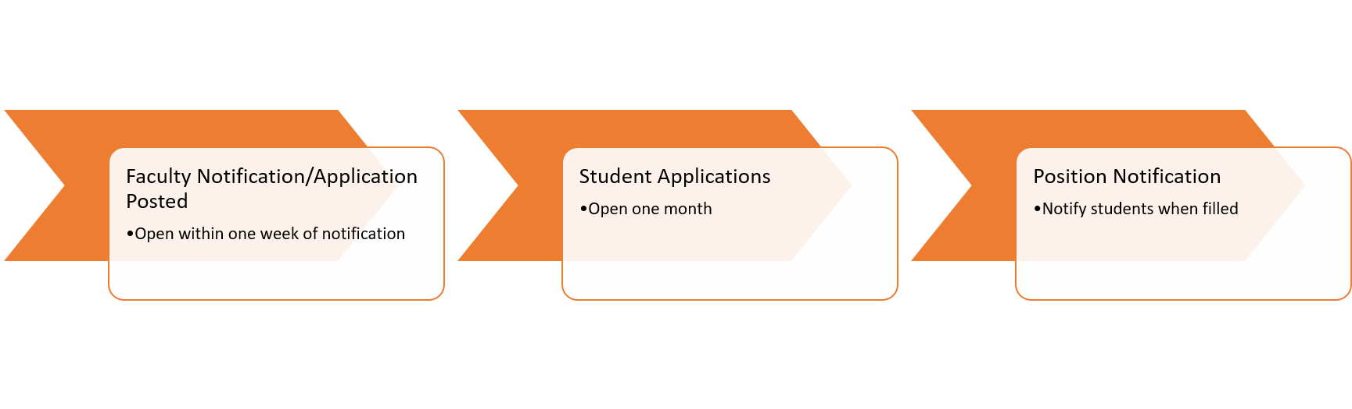

Application Completion and Evaluation
This section of the presentation describes how to appropriately complete the assistantship application by explaining the evaluation process and rubric used by members of the Graduate Student Services Committee once faculty applications are complete. This section also provides examples from successful applications to help faculty understand criterion for the application. You may want to note where examples are shown in the document so you can pause and review these as you write your own application.

Review Process
Once the application window is closed, two members of the Graduate Student Services Committee (outside of the applicant’s college) are assigned to review complete applications. In cases of large discrepancy, a third reader (also outside the college) is assigned to resolve the difference.

In order to be considered complete, the application must have: completed the online form providing all required information and an evaluation method attachment. The following explanation of application information is provided in detail through the examination of application requirements and rubric criterion.

Application Requirements
Applicants must provide their basic contact information:
- Name
- Email
- College
- Department

Applicants then select the category and time commitment of the position for which they are applying.
- Type of assistant required is determined by the project or tasks that will be accomplished by student. If students will not be teaching (TA), -- or assisting in faculty research (RA), --then the correct category to select is the general graduate assistant (GA).
Keep in mind that when selecting the type of graduate assistant that the focus should be focused on mentoring the student and providing maximum benefit to the student. Administrative or office support functions should not be the goal of an assistantship.
- Time commitment for the position is either full or part time: Note that only what is requested will be awarded. A position that is requested at full time will not be awarded at part time instead. Please request what is needed based on the project/tasks required. Assistantships are funded for the fall-spring academic year; therefore, tasks should fall within that time frame as well.

Separate applications must be completed for each position requested. If you are requesting two positions with identical descriptions you should complete TWO applications and note that you are seeking more than one position in the Other, Specify box.

Rubric Overview and Scoring
Each application is evaluated on criterion aligned with definitions of student employment grading as provided by human resources. This allows UF to ensure students are equitably compensated and to comply with labor law practices. The criterion for this definition are:
- Nature of work,
- Benefit to the student,
- Common tasks,
- Knowledge, skills, and abilities,
- Problem solving and decision making,
- Interactions,
- Benefit to the faculty, department, college, and university,
- Impact,
- Supervision,
- Method of evaluation

For each criterion applications are ranked on a scale as follows:
- 5: Exceeds expectations
- 3: Meets expectations
- 1: Below expectations
- 0: No information provided

Using this system an application achieving exceptional in all categories could earn up to 50 points total from each reviewer. Category ratings are not always equal. An application may achieve above average in some categories, but below average in the others.

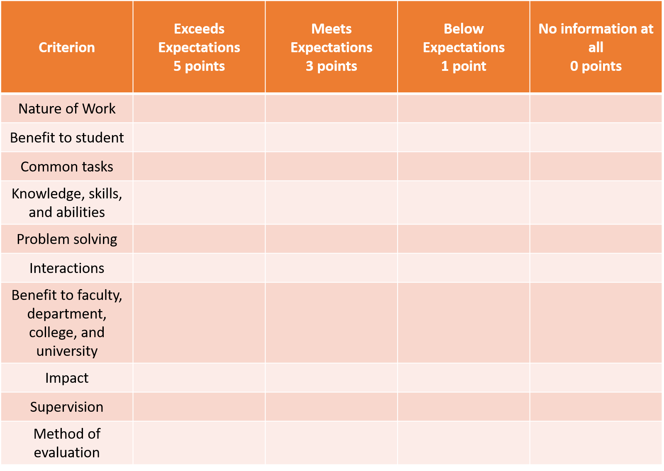
Rubric Specifics
This portion of the presentation will explain each category, criterion for achieving an exceptional rating by examining successful application examples, and noting any significant differences between top and lower rating categories. For all categories a rating of zero is received when information is not provided at all.

Nature of Work
The first rubric criterion is nature of work. Applications can achieve an exceeds expectation rating by addressing all of the nature of work requirements. These include explaining:
- ways the tasks required for the position are varied and may cross several disciplines,
- if work consists of situations or duties requiring interpretation of standard policies and procedures in order to complete tasks for the position
- what training, skill, or experience is required for the position

Lower ratings are received when some or none of the requirements are addressed.

Tips to consider when providing a response for this category are:
- The position should require more than a basic set of skills to complete the tasks.
- Articulate ways in which the position will allow students to build on existing skills to interpret policy or procedure while completing tasks.
- Positions that do not require synthesis of information and/or decision making skills may not be appropriate for this application.

Benefit to the Student
The next rubric criterion is student benefit. Applications can achieve an exceeds expectation rating in this category by including a clear and detailed description of how the assistantship will benefit the student that matches the common tasks description (explained below).

Lower ratings are received when the description is unclear or is not provided.

Tips to consider when providing a response for this category are:
- Benefits and tasks should match one another.
- Giving an example of how students could apply skills learned in the position help indicate benefits clearly.

Common Tasks
The next rubric category is common tasks. Applications can achieve an exceeds expectation rating in this category by addressing all the common tasks requirements. These include explaining if the position duties include:
- providing specific information,
- drafting replies to inquiries,
- advanced accounting related process tasks,
- conducting lab or work group sessions focused on review or application of course materials, or
- grading short essay assignments for accuracy and completeness, or
- assessing performance and progress

Applicants should also note if the position requires any of the following:
- Evening, weekend, and break hours
- Completion of specific coursework
- 3.2 or higher GPA

If one of these options is selected, please specify in the space provided. If none apply, select that option as this will count as providing the information.

Ratings lower than exceeds expectations are received when only some or none of the requirements are addressed.

Tips to consider when providing a response for this category are:
- Be as specific as possible when indicating task information
- Explaining frequency of skill can help provide stronger explanation
- Evaluation of this category allows for and/or – meaning not all of these aspects may apply to your position. However, you should indicate a response for all aspects, even if this is to state it does not apply.

Knowledge, Skills, and Abilities
The next category is knowledge, skills, and abilities. Applications can achieve an exceeds expectations rating by addressing all the requirements for this category. These include explaining if the position requires:
- ability to understand, interpret, apply, and communicate information within a specialization
- ability to apply limited analysis to complete general position functions
- completion of coursework, certification, or field certification
- operation of moderately complex equipment/tools
For any of these requirements noted as necessary, please specify in the space provided.

Ratings lower than exceeds expectations are received when only some or none of the requirements are addressed.

Tips to consider when providing a response for this category are:
- Provide explanation of knowledge, skills, and abilities that are required to do the job, not ones that will be gained through the position.
- Evaluation of this category allows for skills that “may” be required – meaning not all of these aspects may apply to your position. However, you should indicate a response for all aspects, even if this is to state it does not apply.

Problem Solving and Decision Making
The next rubric category is problem solving and decision making. Applications can achieve an exceeds expectations rating by addressing all requirements in this category. This includes indicating the following required for the position:
- level of independent judgement,
- information gathering and/or reviewing, and
- analysis of facts

Ratings lower than exceeds expectations are received when only some or none of the requirements are addressed.

Tips to consider when providing a response for this category are:
- Provide explanation of problem solving and decision making skills that are required to do the job, not ones that will be gained through the position.
- Explain ways in which this position requires an IF-THEN decision making process. For example, tasks for the position should require the student to understand a basic process and then make decisions based on information provided. But each set of information should require differentiated decisions to be made – the same decision or process presented over and over is not significant enough level of effort for positions funded by this application process.

Interactions
The next category assessed is interactions required for the position. Applications can achieve an exceeds expectations rating by addressing all the information required. This includes explaining:
- to what extent contact for this position involves giving or obtaining information (including exchanging advice and options)
- if common business courtesy, tact, discretion, and some persuasion may be required

Ratings lower than exceeds expectations are received when only some or none of the requirements are addressed.

Tips to consider when providing a response for this category are:
- Be as specific as possible when explaining interactions
- Consider not only student-supervisor interaction, but include interactions with both internal and external members related to the position

Benefit to Faculty, Department, College, and University
The next rubric criterion is faculty/department/college/university benefit. Applications can achieve an exceeds expectation rating in this category by a description of how the assistantship will benefit all of the following: faculty, department, college, and the university

Ratings lower than exceeds expectations are received when benefit descriptions only address one or two levels or do not provide this required information.

Tips to consider when providing a response for this category are:
- Benefits and tasks should match one another.
- Giving an example of how faculty can advance scholarly activity for both themselves and UF provides stronger benefit explanation.

Impact
The next category of the rubric is impact. Applications can achieve an exceeds expectations rating by addressing all of the requirements. These include explaining to what extent actions and decisions made by this position affects the immediate work group and areas beyond the immediate functional area, as well as how errors reflect unfavorably on both the individual and functional area.

Ratings lower than exceeds expectations are received when only some or none of the requirements are addressed.

Tips to consider when providing a response for this category are:
- Be as specific as possible in describing both favorable and unfavorable aspects
- Consider not only student-supervisor interaction, but include interactions with both internal and external members related to the position

Supervision
The next rubric criterion is supervision. Applications can achieve an exceeds expectations rating by addressing all the required elements. This includes providing the following information:
- indicate how supervision is given to and received from this position,
- how the work schedule is set,
- any type of feedback that given from the student to the supervisor about the efficiency of this position and its functions

Ratings lower than exceeds expectations are received when only some or none of the requirements are addressed.

Tips to consider when providing a response for this category are:
- Be specific in describing how much input and feedback students will have in setting schedule and selecting tasks.
- Positions that do not allow students to use their own judgement in setting priorities and selecting tasks may not be appropriate for this application.

Method of Evaluation
The final rubric criterion is evaluation of position activities. Applications can achieve an exceeds expectations rating in this category by including an explanation of the evaluation method used for activities by providing explanations of the evaluation and identifying consequences if set parameters are not met.

Ratings lower than exceptional are received when only the evaluation or consequences are defined (but not both) or no evaluation/consequences information is provided at all.

Applicants can use the following tips to consider information that should be defined in this section.

- Clearly identify what the assessment will be. Will it be based on if the student completes tasks well and is meeting identified goals? How will this be defined and tracked (attendance record, task/time log)? Will quality and/or quantity of work (with reasonable adjustments for skill level and unexpected issues) be a factor? –-
- Clearly identify when the evaluation will be performed. Will this be weekly, only at the required mid-term, and/or a final evaluation? Be sure to consider and explain how these evaluations contribute to the student benefit (and mention that in the appropriate section).
- Clearly identify what criterion would cause a student assistant to need a support plan or be dismissed. What would that support plan be, how would you describe that to the student?

Faculty Responsibilities During Assistantship
This section of the presentation describes faculty responsibilities during the assistantship term, including completion of the required mid-term and end-of-position evaluations.

Faculty are expected to supervise students as noted in the assessment section of the application, by keeping in regular contact and communication as the semester moves forward. Faculty are expected to complete a required mid-term and end-of-position evaluation along with any others as noted in the application supporting documents.

These evaluations are completed electronically and submitted to the Graduate Operations Director working in Academic Affairs. These evaluations are included in re-applications and help shape final funding decisions during the review process.

Conclusion
Thank you for taking the time to understand the graduate assistantship application process. Should you have any questions, please contact the Office of Academic Affairs.

