**Cap and Gown Order Form – Spring 2025**

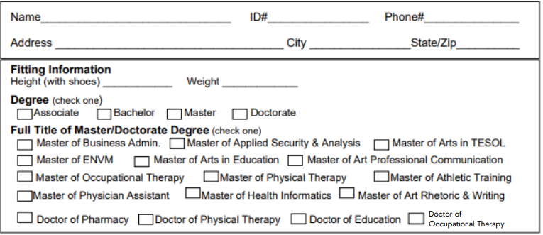Shipping (check one)

Items Ordered (Tax Not Included)

Undergrad

Full Bachelor Unit (Basic plus stole) $120.92 Basic Bachelor Unit (cap, gown, tassel) $84.94

Gown $54.98 Tassel $19.98 Cap $9.98 Stole of Gratitude $35.98

Graduate

Full Master Unit (Basic plus stole) $174.90 Basic Master Unit (cap, gown, tassel, hood) $138.92

Gown $56.98 Hood $51.98 Tassel $19.98 Cap $9.98 Stole of Gratitude $35.98

Doctorate

Full Doctorate Unit (Basic plus stole) $226.90 Basic Doctorate Unit (tam, gown, tassel, hood) $190.92

Gown $65.98 Hood $64.98 Tassel $19.98 Tam $39.98 Stole of Gratitude $35.98

I will be picking up my Regalia Please ship my Regalia $15 per unit (4/1/2024 last day for shipping.

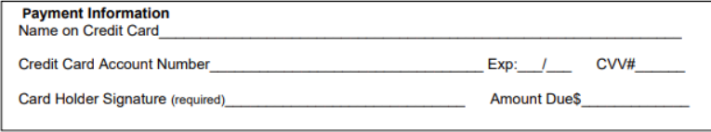

Send your order to Email: SM8491@bncollege.com Pick Up: Regalia may be UF Bookstore picked up in AMU during Senior Salute

301 Davis St.

Findlay OH 45840